August 7, 2023
Southwest Ohio is in the midst of a serious destruction of native plants and habitat due to the invasion of bush honeysuckle. This plant is forming thickets in natural areas so dense that no other plants can grow in its midst. Other parts of the country have serious issues with things like kudzu, multiflora rose and Japanese knotweed, but bush honeysuckle seems to be worst invader around Dayton, Ohio.

Rapid spreading
The plant spreads by producing thousands of berries, each containing a hard-shelled seed. Birds eat the berry, the seed survives passage through their digestive system, and they drop the seed along with some natural fertilizer, sometimes miles from where they found it. So, unlike the vining Japanese honeysuckle that slowly creeps over the ground, bush honeysuckle has spread all over the area quickly after it was introduced and sold by garden centers. It is now outlawed for sale in Ohio.
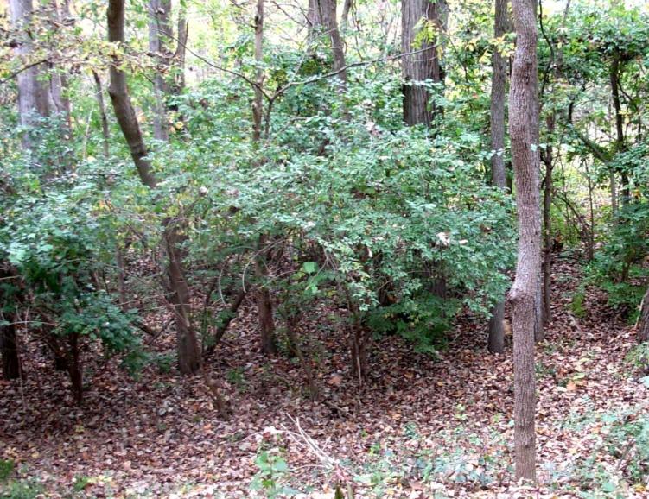
Picture is bush honeysuckle in the fall.

Four ways to kill your honeysuckle
There are several ways to remove honeysuckle, including pulling out small plants, digging out larger plants, cutting the plants down with loppers or a chainsaw and spraying the foliage with a herbicide.
Each of these approaches works in some situations but they are all hard work. Fortunately, honeysuckle is easy to recognize, especially in the early spring and late fall. It leafs out before most native plants and holds its leaves after most natives are dormant in the fall. The plants are generally shrubs but can grow to 15 feet tall. The branches generally arch and sag down as they age. After 20 years or so, the oldest plants often die, but they are promptly replaced by new sprouts.

Pulling
If you have small honeysuckle plants in your garden, fencerows or woods, pull them out as soon as you see them. They grow quickly and will be difficult to pull after their second growing season. Spring walks in the woods (when the ground is soft and wet and the honeysuckle is turning green) is the perfect time for this. If you are a mushroom hunter you might be disappointed at not finding any mushrooms but at least you can leave the woods knowing you stopped lots of honeysuckle from destroying future mushroom habitat.

Digging
If you have some larger plants that are too hard to pull, stabbing a shovel or mattock under the plant, prying up, then pulling will be effective. Bush honeysuckle does not put out “runners” or re-sprout from small pieces of root left in the ground, so you only need to remove the main stump to score a kill.

Cutting
Unfortunately most infestations will have grown beyond the pulling stage before you realize they are a threat, so you will need to cut them down. Loppers, a pruning saw, or a battery operated reciprocating saw (“sawzall”) will work – until you find the BIG ONE. They can have trunks up to 3 or 5 inches in diameter and often grow in a clump so a chainsaw will be required. We try to cut them low, within an inch of the ground, to ensure the herbicide goes directly to the roots and to reduce tripping hazards. Working with sharp tools and powerful herbicide is best done without stumps in your way.
For large areas of dense honeysuckle, a brute force attack with heavy machinery may be used to cut down and shred the honeysuckle. This approach is useful where clearing the honeysuckle out by hand is not practical but also destroys whatever is left of native vegetation and requires extensive follow up to kill the stumps, so it will not be covered further in this article.

Treating stumps
The stump must be treated with herbicide or it will regrow – prolifically. A mix containing glyphosate (“Roundup”) at about 15 or 20% active ingredient concentration works great when daubed directly on the cut face of the stump. This is a powerful herbicide and will kill nearly any plant it touches, so it is important to ONLY get it on the cut stump and not on the surrounding ground or other plants. Some also use Garlon 4, at a similar concentration. Garlon 4 is applied mixed with oil, and some say it is more effective. It is more expensive, but is less toxic to grasses so may be preferred in some cases.
Whichever herbicide you use, add a colored dye to it. The dye makes is easy to tell which stumps have been treated and which have been missed, and also reminds us not to get it on our skin. The manufacturers claim that contact with glyphosate is not hazardous but some studies have shown a correlation between glyphosate use and cancer cases, so minimizing skin contact is advised.
In the past, we used a sprayer to apply herbicide to stumps but found the dauber approach to be much better, using less herbicide and causing less damage to surrounding plants.
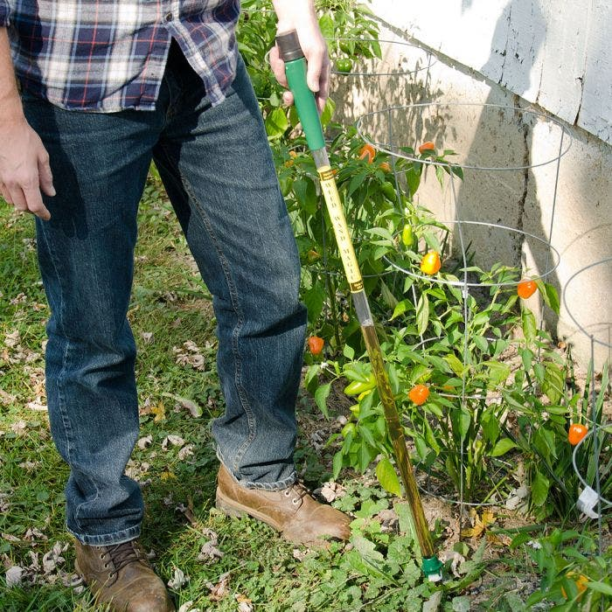 Weed Wand dauber
The only other way to kill the stump is to remove all re-growth foliage every time it appears, a process than can succeed in your yard if you scalp the stump with a lawnmower or trimmer every time you mow.

Foliar spraying
The final method, known as “foliar spraying” is done with a sprayer and a less concentrated herbicide, like a 1% - 2% mix of glyphosate. This is best done in early November after most of the other plants have gone dormant but before the honeysuckle leaves turn yellow. Glyphosate will kill a wide variety of plants, including lawn grass and most native woodland plants, so waiting until the right week in the fall is important. This method works best on bushes that are small (less than shoulder high) and easily accessed, to avoid overspray on desirable plants. It is less labor intensive than the other methods so it is possible to kill a lot of honeysuckle quickly. Try to keep most of the spray on the honeysuckle leaves, but if you are spraying when the other plants are dormant, damage should be minimal.
Some say the herbicide is less effective in stump treatment during the spring rapid growth period but we found one study that recorded a 100% kill rate in winter, spring and summer treatments alike.
It is essential to follow up with an annual foliar spray spot treatment of any new plants or re-growth of stumps that were missed. The alternative is to come back in a few years and find all your work has been undone by this very persistent plant. It is better to keep the honeysuckle out of a manageable area of woodland and let the native plants recover there than to continuously try to cover a larger area and end up with a woods full of smaller honeysuckle plants.

Shade as a toxin
When you clear a dense stand of honeysuckle, you will find that there are few, if any, other plants left (except, of course, large trees). The honeysuckle plant shades the ground completely, preventing all but the most shade-loving plants from growing. Some say it also produces a toxin that kills other plants but we have not found specific evidence of this. Shade seems to be the “toxin” honeysuckle uses to kill anything that relies on photosynthesis to survive. This the most important reason to attack honeysuckle with a vengeance! It is fundamentally changing the balance of nature, replacing our native plants with a monoculture of useless honeysuckle. Even the tall hardwoods will eventually be lost if no young trees are able to sprout and grow to become replacements for old trees.

Clean up or focus on the killing?
Honeysuckle bushes have lots of branches that fork in all directions so you will have lots of unsightly brush to deal with when cutting larger plants. No one likes messy scattered brush in the woods so we usually try to stack it, at least enough so you can easily walk through the cleared areas. Piles can be reduced in size by cutting it in smaller pieces with loppers or a chainsaw. In very visible places like a yard or public park you may need a chipper to deal with all the debris.
In a less visible woodlands you may want to kill the honeysuckle and not worry about cleaning up. We always find more honeysuckle than we have time or manpower to remove so time spent carefully stacking and cleaning up just takes away from the time we can spend cutting and daubing. Bushes chopped up and left on the forest floor will decompose in time, just as all woodland trees do naturally, so even making piles is not necessary in many cases.

Mixing herbicides
You can find products containing glyphosate at the hardware store or garden center with (1% to 5%???) active ingredient and this can be used successfully on small infestations.
The more concentrated form available at farm stores (Tractor Supply, Rural King, etc) is typically 41% active ingredient. Diluting this product 2:1 with water gives 13.6% active ingredient, which is close enough. Some sources recommend using 20% concentration on stumps, so the exact number is not critical.
You can check the mixing ratio by dividing the percent active ingredient by the number of units of water added plus 1. So, if you add two cups of water to one cup of 41% glyphosate product, you get 41/3 = 13.6% concentration.
If you add 20 cups of water to 1 cup glyphosate product, you get 41/21 = 1.95% active ingredient which, again, is close enough.
Don’t forget the dye. Ordinary food coloring works. Dye made for this purpose is available, and it only takes a little (a teaspoon per gallon?) to make the mixed herbicide very visible.

Other invasive plants
We have scattered infestations of autumn olive, callery pear, multiflora rose, euonymus (winter creeper), alanthus (tree of heaven), privet, kudzu, and others, in the Dayton area. During honeysuckle hacking sessions, we often cut these other species down and treat the stumps with the same glyphosate mix we use on honeysuckle. This is not the most effective treatment for some of them, but because they are not spreading as fast (sometimes being overcome by the spreading honeysuckle) this limited treatment might be adequate.
A good video summarizing many of these points can be found at: https://extension.psu.edu/invasive-shrub-control-strategies

This article was written by Jim Byrd, a honeysuckle hacker with experience helping B-W Greenway Community Land Trust, Greene County Parks and the Beaver Creeks Wetlands Association remove invasives.

OSU extension fact sheet “Controlling Non-Native Invasive Honeysuckle in Ohio Forests: Bush Honeysuckle”
Weed Wand Magic example dauber: https://www.amleo.com/weed-wand-magic-applicator/p/WWA
“Use of Herbicide in the Eradication of Honeysuckle (Wisconsin)”, Thomas D. Brock, E. B. Fred, University of Wisconsin-Madison

